Installing Critical Patch

1. Download the CPS patch set and unzip the download to a Staging Folder

* The CPS is a self contained download.
* No additional downloads are needed to install the CPS
* For additional information see [FAQ : Critical Patch Sets (CPS) for PTC Windchill](https://www.ptc.com/appserver/cs/view/case_solution.jsp?n=134275)

2. Stop Windchill and Apache / HTTPServer  
  
3. Start WindchillDS if it is not already running  
  
4.Open the**<CPS staging>/<PTCSolnInstaller>**  
                Where  **<PTCSolnInstaller> =** PTCSolnInstaller.01 or  PTC_Solution_Installer_<Windchill version code>  
      a. Windows Operating System : run **setup.vbs**to launch PSI  
      b. Linux Operating System : run **setup (setup.sh)** to launch PSI  
      **Note:** Make sure to grant full control on Windchill_Home.  
  
5. Accept the license agreement  
​**Note:** The PSI may report a different CPS version than the CPS being installed  
This is expected behavior  
See [CS213426](https://support.ptc.com/appserver/cs/view/solution.jsp?n=CS213426) for additional information  
Provided the PSI being run is the one included in the CPS kit this discrepancy can be ignored.

6. Select **'Update Existing Installation'** and click **Next**  
  
7. Select the instance to apply the CPS to and click **Next**  
  
8. Select **'Install Critical Patch Set**' and click **Next**  
  
9. Make sure that both the CPS Staging Area directory and the original Install Staging Areas are selected. Click **Next**  
  
10. Proceed through the rest of the PSI screen the same as for installing a Maintenance Release  
11. Make sure that all the needed CDs can be found in Staging Areas  
  
12. Click **Install** to install the CPS  
13. Make sure that the installation completed successfully  
14. Start Apache / HTTPServer  
  
**Note:** The following steps are only required for 10.2 F000 CPS updates

15. From a Windchill shell, run

**update_tool -noui**

16. Make sure that update_tool runs through without error

* The CPS is now applied and Windchill can be started

* Installing in a Cluster
  + Like a Maintenance release, the CPS should be applied to one node and the node then cloned to the other systems
  + See the Installation and Upgrade guide for more information on updating clusters

* Installing on a File Server
  + The CPS install will update the CCSDSU.zip file just like a Maintenance Release
  + The CCSDSU.zip will need to be deployed to all the File Servers the same as a Maintenance Release

**Note on Windchill Version**

* After installing a CPS the Windchill Version will reflect only changes for the affected modules
* In case a module has been updated by a previous CPS but not the latest one a difference in **Supported Datecode** and **Release Id**will be seen when running the **windchill -version** Windchill command, e.g.

      Support     Support                                     Installer  
      Datecode    Release Number  Release Id                  Sequence   Display Label  
  --  --------    --------------  ---------------             ---------  ---------------------  
      M020-CPS06  10.2            solr.10.2.20.06.04          01         PTC Windchill 10.2 Index Search  
      M020-CPS08  10.2            wsp.10.2.20.08.04           02         PTC Windchill 10.2 Service Pack

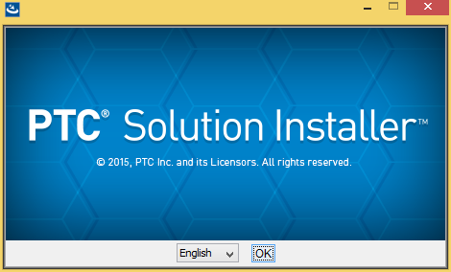 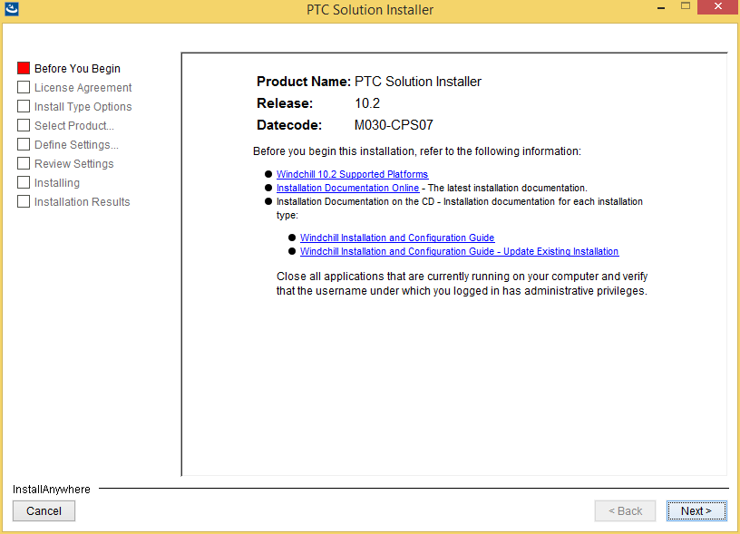 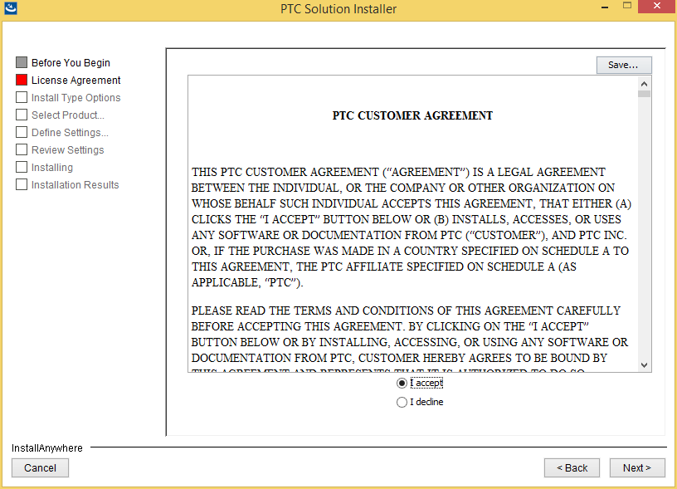 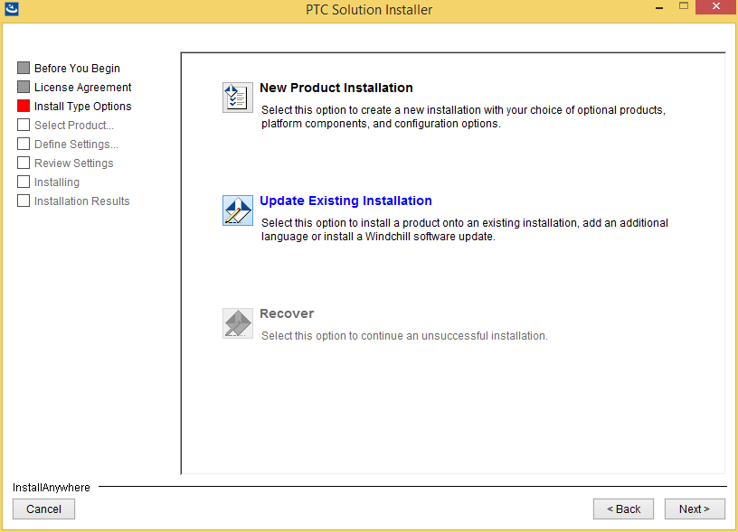 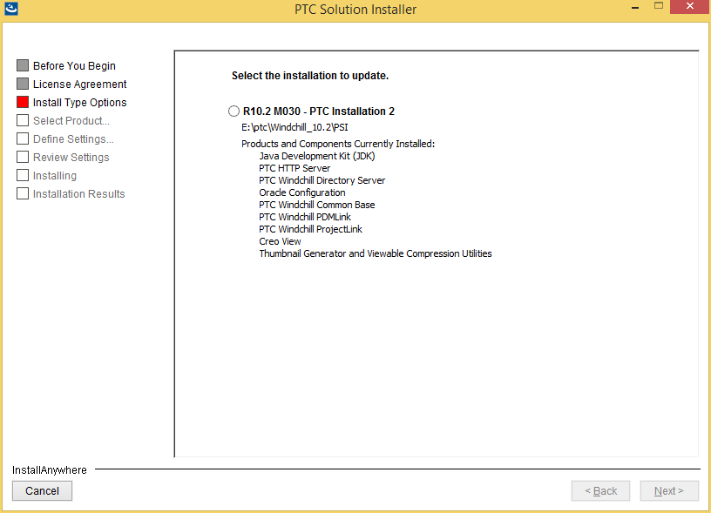 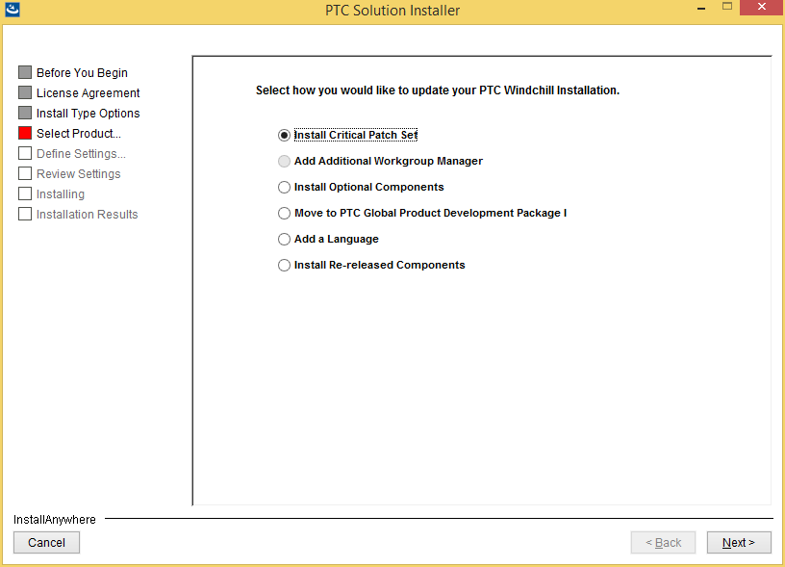 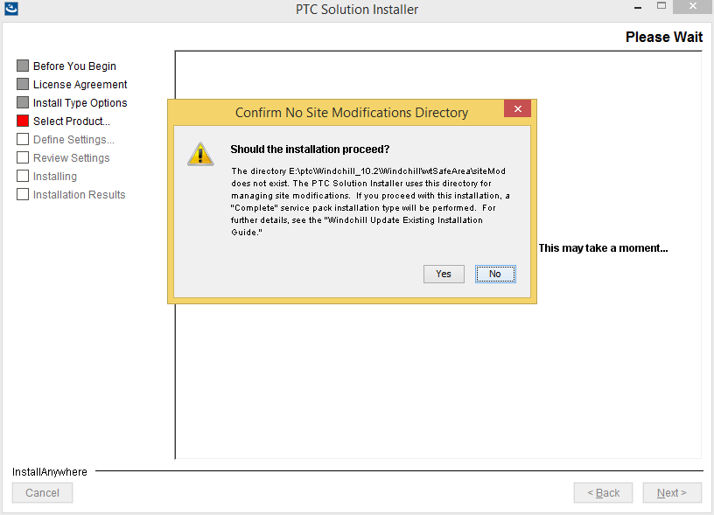 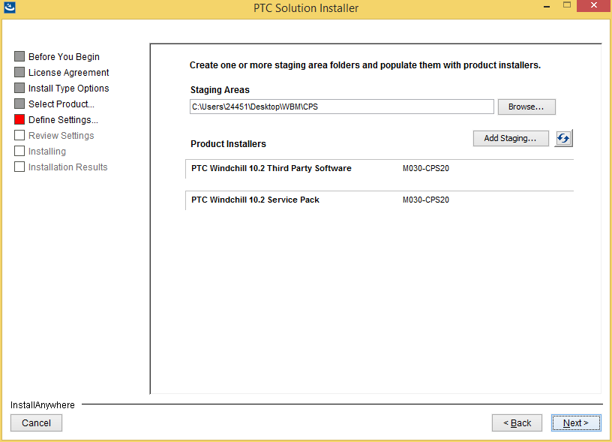 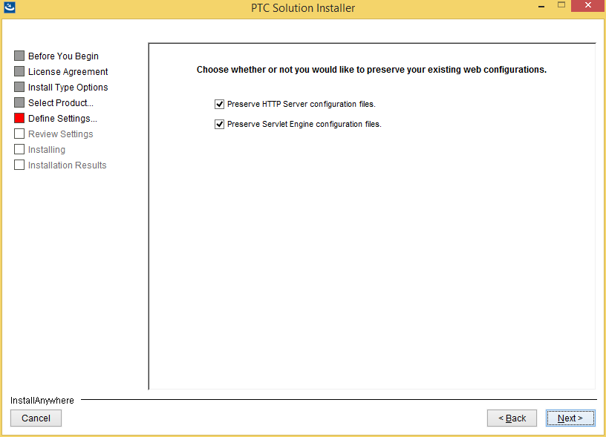 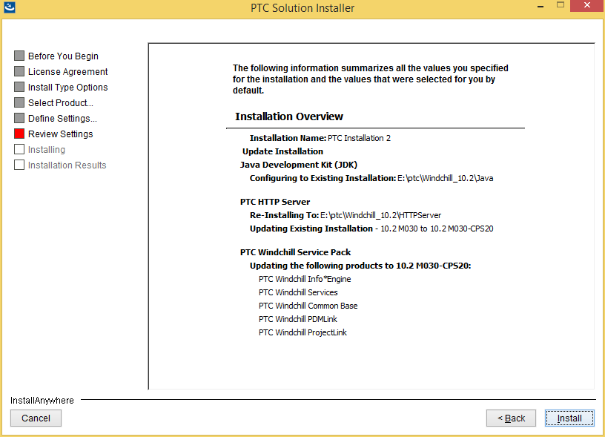 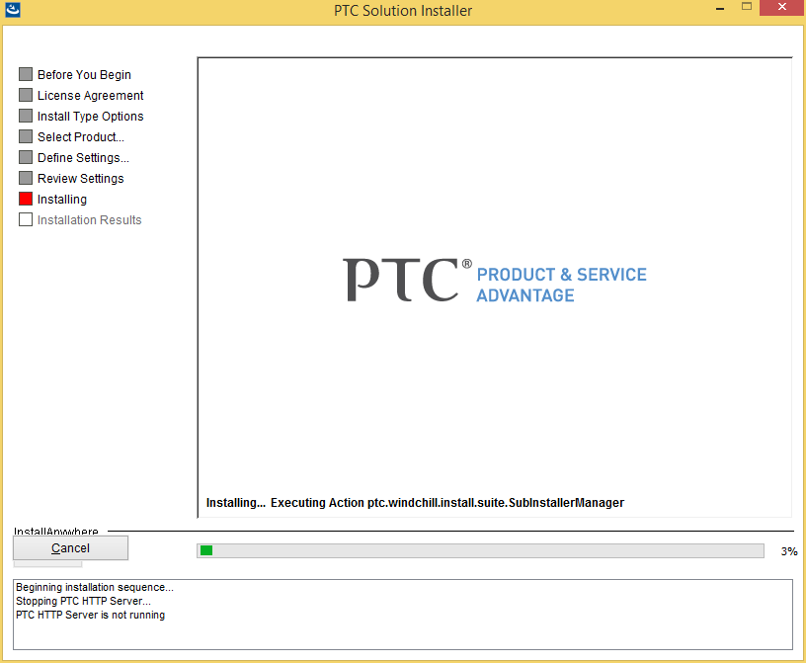 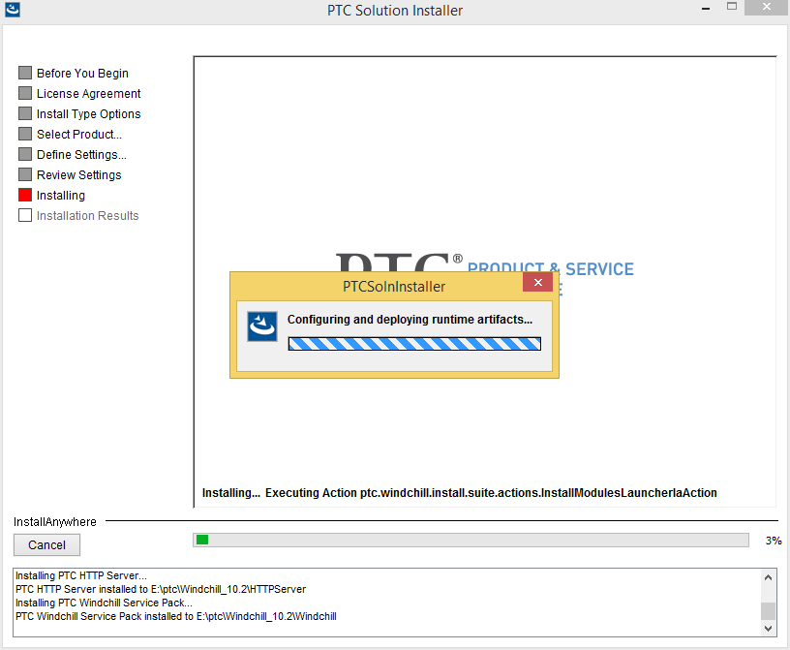

ERROR : com.ptc.windchill.upgrade.statemachine.UpgradeFrameworkStateMachine - State execution failed (with return type FAILED): ReportWriterUpgradeState(Up

grade Database Schema)